Vincent Pham 03/27/2023

Module 7 Testing Assignment

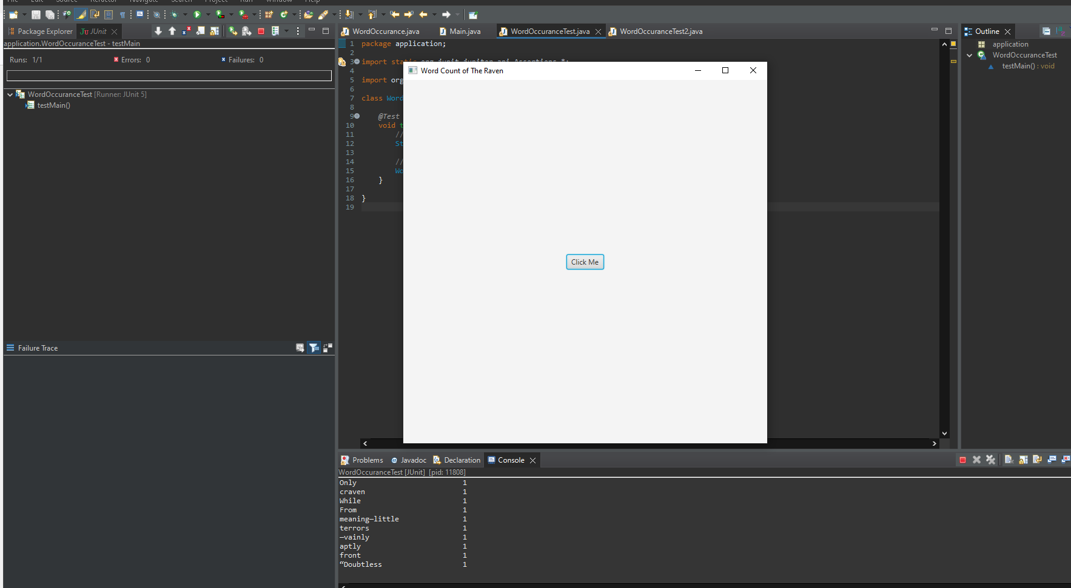

First screen shot of running program.

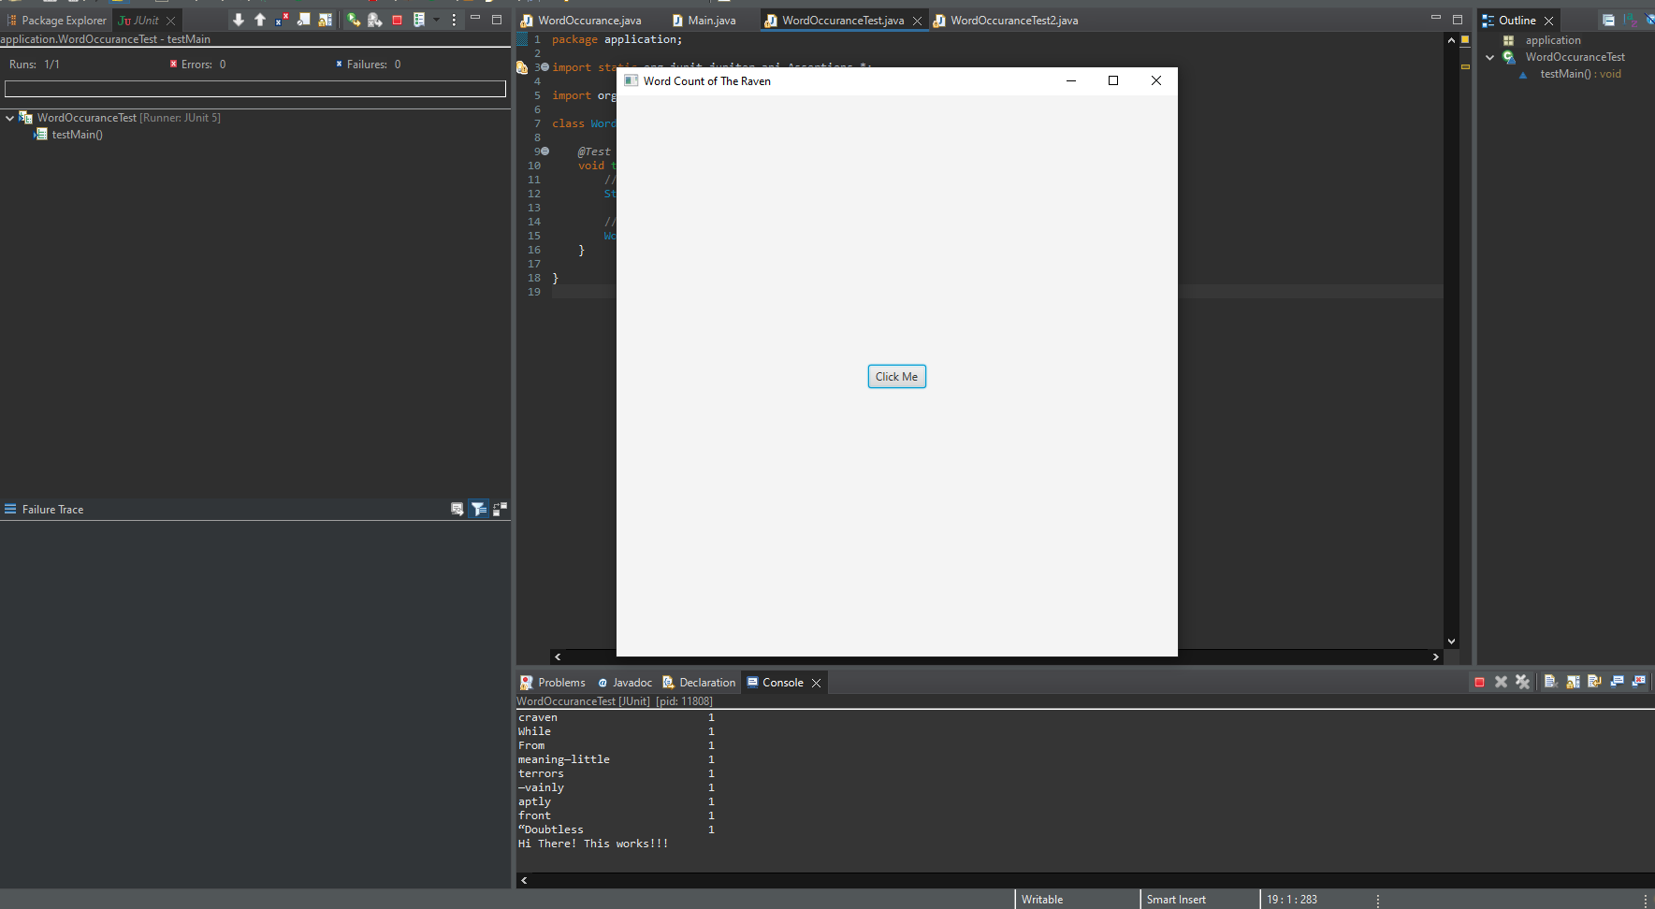

Clicking the button Click me shows the response Hi There! This works!!!

After exiting the GUI it was ran successfully.

This example shows testHandle testing handle method by creating instance of the MyHandlerTest creating an input list of two strings of hello and world. As long as it asserts the string helloword then it will run. If not then it would fail.